LACUATA, Ara Belle P.

2 ECE-C

**X_normalized**

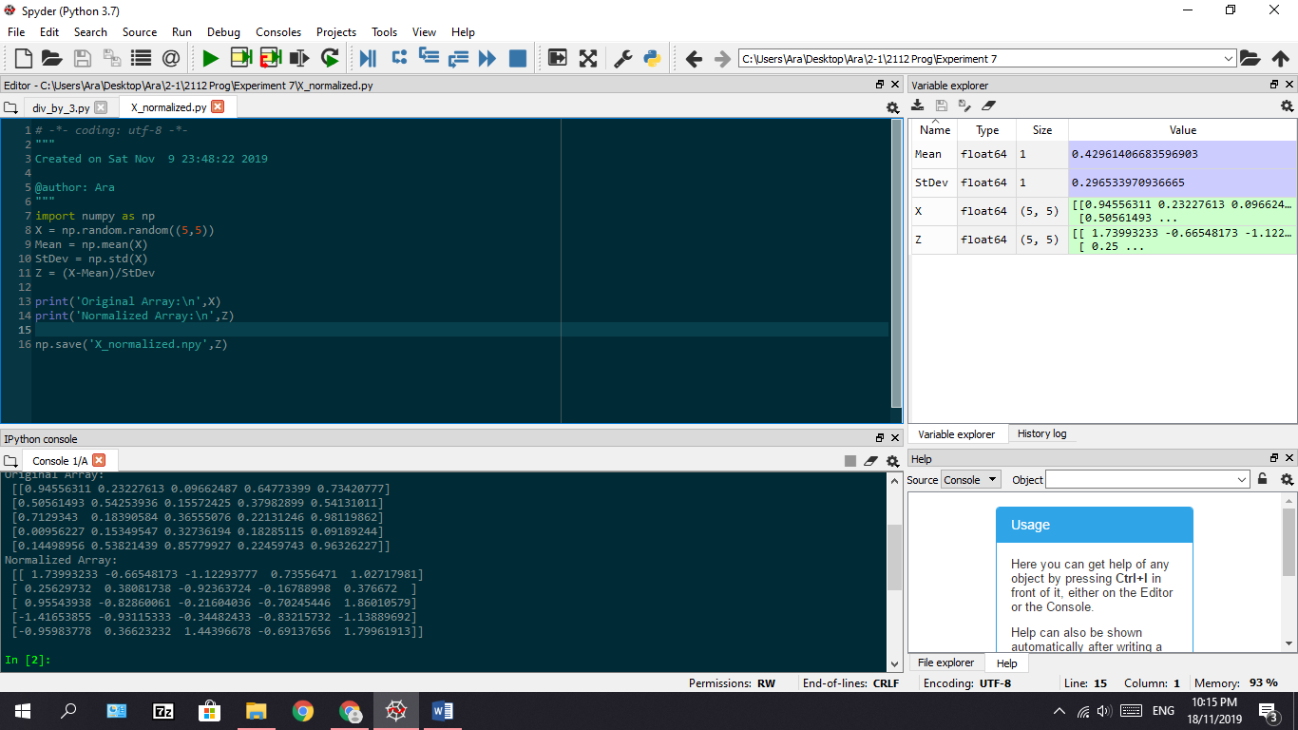

**div_by_3**

